Psychology Department: Summer Study Tasks

Cognitive Psychology: At the start of yr. 1 you will begin by learning about human memory. The following QR code or URL provides a simple overview of memory models. Use the website to help you complete task 1 and 2.



URL: [10 Influential Memory Theories and Studies in Psychology - Psychologist World](https://www.psychologistworld.com/memory/influential-memory-psychology-studies-experiments)

Task 1

The memory models that are particularly important to us are the **Working Memory Model** and the **Multi Store Memory Model**. Please make brief notes on each model to prepare for the start of the cognitive psychology topic.

Task 2

A knowledge of ‘flash bulb memory’ and the implications of errors in memory in eyewitness testimony is also important to help us critically analyse memory processes.

What is meant by **‘flashbulb memory’**?

Why is **eye witness testimony** flawed?

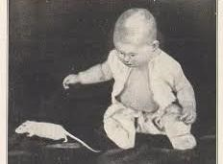Learning Theories: Watson and Rayner (1920)

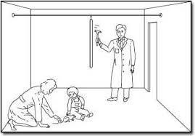Little Albert was a 9-month-old infant who was tested on his reactions to various stimuli. He was shown a white rat, a rabbit, a monkey and various masks. Albert described as "on the whole stolid and unemotional" showed no fear of any of these stimuli. However, what did startle him and cause him to be afraid was if a hammer was struck against a steel bar behind his head. The sudden loud noise would cause "little Albert to burst into tears.

When Little Albert was just over 11 months old the white rat was presented and seconds later the hammer was struck against the steel bar. This was done 7 times over the next 7 weeks and each time Little Albert burst into tears. By now little Albert only had to see the

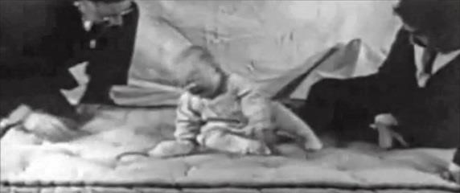rat and he immediately showed every sign of fear. He would cry (whether or not the hammer was hit against the steel bar) and he would attempt to crawl away.

In addition, the Watson and Rayner found that Albert developed phobias of objects which shared characteristics with the rat, including the family dog, a fur coat, some cotton wool and a Father Christmas mask! This process is known as generalisation.

Watson and Rayner had shown that an association could be used to create a phobia. A phobia is an irrational fear, i.e. a fear that is out of proportion to the danger. Over the next few weeks and months Little Albert was observed and 10 days after conditioning his fear of the rat was much less marked. This dying out of a learned response is called extinction. However, even after a full month it was still evident, and the association could be renewed by repeating the original procedure a few times.

Issues and Debates: Debates are an important part of Psychology. We will consider whether classic studies such as the Little Albert study is considered ethical…

Ethics

Ethics refers to the correct rules of conduct necessary when carrying out research. We have a moral responsibility to protect research participants from harm.

**Informed consent** - Whenever possible investigators should obtain the consent of participants. In practice this means it is not sufficient to simply get potential participants to say “Yes”. They also need to know what it is that they are agreeing to. In other words, the psychologist should, so far as is practicable explain what is involved in advance and obtain the informed consent of participants.   
**Protection from harm** - Researchers must ensure that those taking part in research will not be caused distress. They must be protected from physical and mental harm. This means you must not embarrass, frighten, offend, or harm participants.   
**Confidentiality** - Participants, and the data gained from them must be kept anonymous unless they give their full consent. No names must be used in a [research report.](https://www.simplypsychology.org/research-report.html)   
**Right to withdraw** - Participants should be able to leave a study at any time if they feel uncomfortable. They should also be allowed to withdraw their data. They should be told at the start of the study that they have the right to withdraw. They should not have pressure placed upon them to continue if they do not want to.

Task 3

Answer the following question: ***To what extent do you think Watson & Rayner’s study is ethical?***

[You must make reference to the ethical considerations above.]

Another debate that we might consider is whether aggressive behaviour is a result of nature or nurture.

Task 4

What is meant by **nature**?

What is meant by **nurture**?

Task 5

Read the following article *“Intruder killed in pensioner's home was wanted over another burglary”* using the QR code or the URL provided.

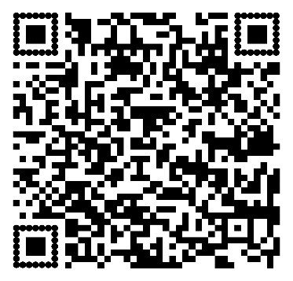

URL: [https://www.theguardian.com/uk-news/2018/apr/05/man-78bailed-over-fatal-stabbing-of-suspected-burglar](https://www.theguardian.com/uk-news/2018/apr/05/man-78-bailed-over-fatal-stabbing-of-suspected-burglar)

***To what extent do you think aggression is a result of nature or nurture?***

Task 6

Using the internet to support your work, begin to research some of the key psychologists you will learn about in your first year included in the list below:

* Milgram (research on obedience)
* Professor Adrian Raine (a psychologist who researchers the brain of those convicted with serious cases such as murder).
* Skinner (including his work on operant conditioning)
* Pavlov (including his work on classical conditioning)