Summer homework, part one of the Pass criteria for the coursework.

This Photo by Unknown Author is licensed under CC BY-ND

Unit 1 P3 task – Assignment Brief:
Title of the essay : Building positive relationships in health and social care – a person centred approach

What the exam board are looking for: P3, ‘Explain strategies to ensure a person-centred approach in health, social care or child care environments’
(Explain = to give account of the purposes or reasons)

Submission date: Hard copy - first lesson of health and social care, electronic copy second lesson of health and social care.

Task: use the two case studies below to link the theory to real life.
How to structure your work: Read the case studies.
Case study 1:
- Give a brief summary of the scenario, describe the person and some of their difficulties and needs.

- Read about the eight elements for a positive relationship in health and social care and then choose three out of these eight elements: Individuality, Choice, Privacy, Dignity, Respect, Rights, Independence, Partnership of person-centred care and explain how they would be shown in this case study and how important they would be in helping the person in the case study.

- Find out what person centred care is and give a definition. Next, explain what the benefits of person-centred care are for the individual in the case study.

Here’s a brief explanation to help you understand:
‘Person centred care is about ensuring the people who use our services are at the centre of everything we do. It is delivered when health and social care professionals work together with people, to tailor services to support what matters to them. It ensures that care is personalised, co-ordinated and enabling so that people can make choices, manage their own health and live independent lives, where possible’ Person centred care - NES (scot.nhs.uk)

- For each bullet point below*, explain what strategies might be used for this person and how that would be beneficial for this individual.

  - *Person centred strategies:
    - Understanding individual needs and preferences i.e., do they have learning difficulties, dietary needs, someone to speak on their behalf?
    - Enabling and supporting an individual i.e. providing a hearing loop, access ramps
    - Staff training i.e. Safeguarding training, risk assessment
    - Demonstrating professional behaviour i.e. being respectful, abiding by confidentiality

Case Study 2:
- Now the next case study – give an outline of the person and their difficulties and needs. Again, give some examples of strategies for each of the bullet points on the list* (see above) and explain how they would be useful for this person.

Case Studies

Case Study 1
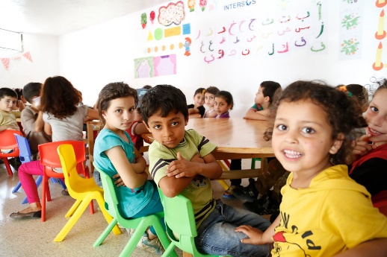
Chloe is 8 years old and has learning difficulties. Due to her learning difficulties, she finds it hard to make friends and often struggles to understand what is going on in lessons. Due to this Chloe can often get told off as she is often caught off task. When Chloe is nervous, she will go to the toilet and can often hide out there for long periods of time to avoid doing work in class. During lunch time she sits on her own while she watches her classmates play. Chloe has a wide range of interests however does not like talking to new people and will often take a long time to open up to people that she does not know.
This Photo by Unknown Author is licensed under CC BY

Case study 2
Mr. Roger Davies was diagnosed with Alzheimer’s disease three years ago and he is progressively deteriorating. When Mr Davies is having a good day he begs his wife, Cassandra not to leave him. Cassandra is struggling with his care and she is becoming very concerned about his safety as he has left the house on a number of occasions when she has been asleep. She is exhausted and her own health is starting to suffer as a result of Roger’s condition. This has resulted in their daughter, Lucy, staying over four nights a week so that Cassandra can rest.
This Photo by Unknown Author is licensed under CC BY-SA

Where you can, add quotes i.e. ‘Building positive relationships with adults, children and young people requiring care is an essential part of effective practice’(1)

Then have a bibliography/reference list at the end of your work i.e.
- Maria Ferreiro et al (2022). Cambridge Technical L3 Health and Social Care . London : Hodder. 3.
‘Neils tool box’ is helpful to show you how to build quotes Harvard Reference Generator :: Referencing a Book for a Student's Essay, Thesis or Dissertation | Neil's Toolbox (neilstoolbox.com)

Useful websites

What is person centred care? Person centred care explained. (theaccessgroup.com)

Person-centred care – BMJ Improvement Hub

Person-centred care: Prevention practice examples and research - SCIE

An example of how this might be written:

This piece of work documents how building positive relationships in health, social care, or childcare environments allows for a person-centered approach to care to be used and how this can impact the individuals that are linked to it.

Individuality - Individuality is an important part of creating a person-centered approach to care for an individual. Individuality allows a person's individual needs to be catered for by setting out the specific needs that an individual has. The person is respected for who they are and having their own identity. Individuality is all about a person being themselves and accepted for that. It allows care workers to get to know each service user individually. ‘One size fit’s all’ does not work when it comes to providing care and support. (1) This is further explained by Active Social Care who say, “it is not about making people fit into services but about providing services which are tailored to meeting a person’s needs.” (2)

Choice - When using a health, social care, or childcare service, giving choice to an individual is the best way to allow an individual to feel valued and included. Having a say over the choices and decisions made about them will allow an individual to be empowered. Making their own choices when using health and social care services creates a feeling that an individual still has control over their life and this make them feel like they are still important. Individuals should be supported to make their own choices. Choice is a basic human right in health and social care and can range from something as small as choosing what to wear to something more important like what treatment the individual would like.

