Dear Art student,
Here is your summer assignment😊
Identity Factors: An individual’s identity is made up of many different factors.
Consider. What is important to you? How would you describe yourself? Write ten words that are central to your identity. These words can be anything, including social categories such as ethnicity and gender, adjectives describing your personality, issues or beliefs you care about, and your favourite pastimes and activities.
Create. Make a self-portrait! You can draw, paint, print, shoot or collage.
We look forward to welcoming you to your course and seeing your self-portraits.
Here are a few examples by Egon Schiele, Lucian Freud, David Hockney and Sarah Lucas:
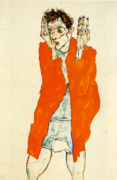 | Self-portrait with Raised Arms from 1914 by Egon Schiele  Medium: Gouache and Pencil
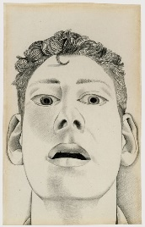 | Startled Man Self-Portrait from 1948 by Lucian Freud  Medium: Pencil
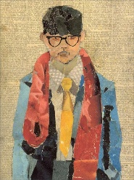 | Self-Portrait from 1954 by David Hockney  Medium: Collage
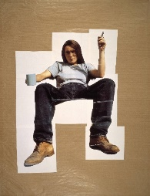 | Self-portrait with Mug of Tea from 1993  Medium: Photography (Digital Print on Paper).

