Business Summer Activity
Issue Date: 5th July 2023 Due Date: 6th September 2023

During the summer break you are expected to complete the tasks detailed below. All tasks relate to Unit(s) you will be studying in the first year at Shrewsbury College and will contribute to your first assignments. Your Tutor(s) will be requesting your work during your first week at Shrewsbury College.

Task 1:
During your first couple of weeks at College you will be working in teams to undertake different tasks. In a team, members are usually allocated different roles which contribute to meeting the objectives of the team.
Your task is to research ‘Belbin’s 9 Team Roles’, identifying each of the roles and a short description of each. https://www.belbin.com/

Task 2:
There are many people, organisations and groups who have interests in different businesses and are affected by the actions of a business. These are called ‘Stakeholders’. Different stakeholders include:
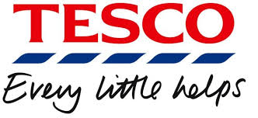
- Customers
- Suppliers
- Local Community
- Pressure Groups
- Government
You are to provide a definition for each of the above stakeholders and describe the interest they would have in Tesco.

Task 3:
As part of your course, you will learn about Marketing. In order to prepare you must research the:
- Role of the Marketing Department
- Ansoffs Matrix
- Marketing Mix (4 P’s)

Please ensure your work is presented in an organised way and your name and titles are on each page.
Good luck and see you in September!

