Pre-enrolment starter pack for the General construction programme Flr1Con. 2023

Name ………………………………….

Useful Websites
https://www.goconstruct.org/
https://www.brick.org.uk/
https://www.constructionnews.co.uk/
https://www.building.co.uk/news/trending
https://www.cityandguilds.com/

Have a go at this quiz and find which construction personality type you are. Click on the link.

https://www.goconstruct.org/learn-about-construction/find-the-role-for-you/ultimate-quiz/
As a starting point for your new learning journey I would like you to research some construction related fun facts. You can use some of the useful web links or try your own. Here’s one to get you started. Try to find another 8 that we can share in the classroom.
- The Shard is the tallest building in Europe and houses 11,000 glass panels.
- ………………………………………………………………………………………………………………………………………………………………………………………………………………………………………………………..
- ……………………………………………………………………………………………………………………………………………………………………………………………………………………………………………………..
- ………………………………………………………………………………………………………………………………………………………………………………………………………………………………………………………
- ……………………………………………………………………………………………………………………………………………………………………………………………………………………………………………………….
- ………………………………………………………………………………………………………………………………………………………………………………………………………………………………………………………
- ……………………………………………………………………………………………………………………………………………………………………………………………………………………………………………………….
- ………………………………………………………………………………………………………………………………………………………………………………………………………………………………………………………..

In what city is the Shard located?..................................
On our course there will be a range of trade areas that we will be exploring. To get you thinking try to find the difference between these trades

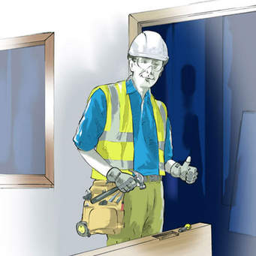

Site Carpenter and Bench Joiner

…………………………………………………………………………………………………………………………………………………………………………………………………………………………………………………………………………………………………………………………………………..
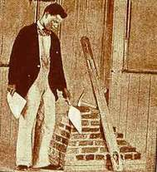

Bricklayer and Stonemason

……………………………………………………………………………………………………………………………………………………………………………………………………………………………………………………………………………………………..
Throughout your learning journey we will look at the vast amount of materials and components used in the construction industry. One being concrete.

Try this true or false questionnaire on concrete.

- Concrete is made up of aggregate, cement and water – True/False.
- Concrete can also be made up of sand taken from the beach-
True/False.
- Cement is used to make the concrete set or cure over time
True/False.
- There are two main types of aggregate called coarse and fine.
True/False.
- When concrete is set the colour will change to a bright white
True/False.
- Steel can be used to make reinforced concrete.
True/False.
- Concrete is fire resistant and has become the most common building material in the world.
True/False.
There are many ways of using concrete which can be an advantage. Complete the statement below by filling in the missing words. This will also be a topic we will discuss when you start your course which will coincide with your own application you will carry out in the workshop.

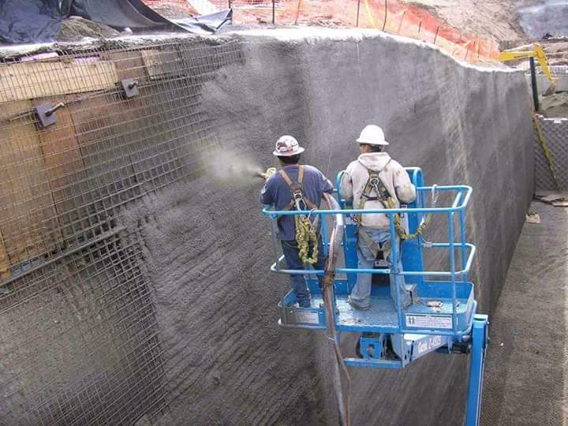

one of the major ………………… of ………………….. is its ability to be used in different ……………………….. methodologies. Concrete is hand …………………, poured, ………………. pumped, sprayed, grouted and used for advanced applications like shotcreting in………………………...

Tunnels. Concrete. Application, advantages, applied.
A very important stage of mixing concrete is the ratio.

Ratios are used to show how things are shared. For example, the necklace in the image has a pattern of two red beads for every three yellow beads.

The ratio of red beads to yellow beads is
Can you research some common ratios that can be used when mixing concrete? Write them down and state which part relates to which material. Remember the materials used to make concrete from earlier study.
Mix 1 | Mix 2

Try This

James and Helen get pocket money in the ratio . The total amount of pocket money they are given is £24. How much money do they each get?
Answer -
During your first sessions in the workshop you will be required to wear and use PPE.

What does the abbreviation P.P.E. stand for?
………………………………………………………………………………………………
The video link will give you some reasons for using PPE.

https://www.youtube.com/watch?v=8o8aBkAXZPw

What do these safety signs inform you to do?

………………………………………..
………………………………………………………
……………………………………………………
……………………………………………………….
…………………………………………….

Remember that when you enrol onto the course you will need to produce

GCSE Results.
Any proof of Learning support.
Medication listing if using.

Remember that when you start the course in September you will need to produce

Safety boots.
Pen.
Timetable.
Workwear clothing.

Tutor’s Email
steventh@shrewsbury .ac.uk.

