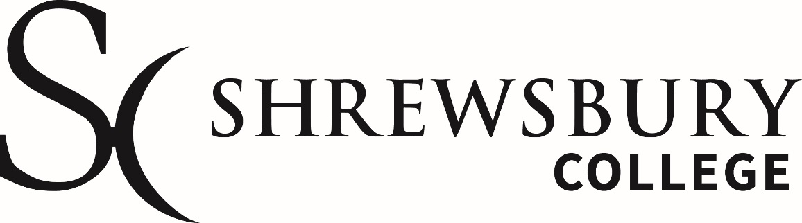

Engineering Summer Assignment document for:
C&G Diploma in Engineering
Level 2 Fabrication & Welding
September 2023 – July 2024

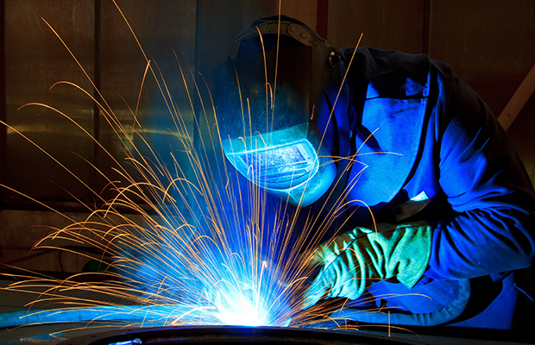

Name of learner:______________________Date:_______________

Contact Information

Course Leader/Contact | Warren Hughes
Email | warrenh@shrewsbury.ac.uk
Introduction to this summer assignment:

This provides you with:
- An introduction to the course subject material.
- Details of basic resources to use.
- Opportunity to demonstrate how you use research.
- How you will be assessed.
- How you will get feedback
Your chosen course is structured in such a way, as to build upon your knowledge and skills from the very first week of the course, through to the end. You course will be delivered using various methods, from theory based, through to practical workshops.

What is the purpose of this assignment?
To demonstrate what you have learned in the welcome sessions and how you can expand this, using research from links provided and further research from websites and further reading which is available from a library or other free resources.
This will link to the two units covered in the first term of the academic year starting in September 2022.

These units are listed below:

Unit 201 Working in Engineering Sept 23 – December 24

This is a theory-based unit delivered in a classroom environment covering all aspects of working within an engineering environment. Subjects include:
Learning outcomes
There are four learning outcomes to this unit. The learner will:
1. Know engineering health and safety requirements
2. Know effective methods of communication
3. Understand drawings and specifications
4. Know about working in engineering
Assessment will be covered by an online multiple choice exam in November 2022.

Unit 214 Welding by MIG process Sept 23 – December 24

Practical based unit with the following outcomes:
Learning outcomes
There are four outcomes to this unit. The learner will:
1. Know safe working practices associated with MIG welding
2. Know how to prepare MIG equipment and materials for welding
3. Be able to produce standard welded joints safely using MIG welding
4. Be able to visually check welds for defects
Assessment as unit will be marked practical work combined with a short answer exam paper in November 2022.

Free resources list for both online and public library

Health and safety:
HSE: Information about health and safety at work, covering COSHH, PPE, PUWER, accidents in the workplace and regulations.
https://www.hse.gov.uk/
Resource link to unit 201 see below:

Mig and Mag welding resources found online from TWI (the welding Institute)
Presentation link below:
General library resources on Engineering and Welding

How will you be assessed?

You will be asked questions in the assignment paper and see the appropriate marks for the complexity of answer required.
Example 1:
Name two hazards that are present with a MIG welding process? (2 marks)
Example 2:
Name two hazards of a MIG welding process and state what safety equipment you would use to protect the person welding, from these hazards? (4 marks)

How will you get feedback?
You will hand the assignment in to your subject tutor at the start of the academic term and they will mark the document and give written feedback alongside the score of what you have achieved, ready for the following week.
This will help you to prepare for upcoming theory and practical sessions, and give you focus towards the progress tests that are 4 weeks into the new term.
Remember to submit your work in a presentable manner, if it cannot be read by the person marking, it will not achieve marks for that question.

Assignment Question Paper Level 2 Fabrication and Welding

- State three hazards associated with MIG welding. (3 marks)

- For each identified hazard state the Personal Protective Equipment (PPE) that should be worn. (3 marks)

- State two types of shielding gas used for MIG welding low carbon steel.
(2 marks)

- Show by means of a labelled sketch, the equipment set-up for MIG welding, identifying six of the following components. (6 marks)

a. Power source.
b. Negative return lead and clamp.
c. Welding and machine earths.
d. Positive welding torch and lead/harness.
e. Gas cylinder.
f. Gas pressure regulator.
g. Gas flow meter.
h. Wire feed unit.
Use the space below (see the MIG presentation for support with this)

- What is COSHH, what does it cover and how does it apply to welding and fabrication? (6 marks)

- What is PUWER, what does it cover and how does it apply to the workplace?
(6 marks)

- What is RIDDOR, what does it cover and when does it apply? (6 marks)

- Can you draw the symbols for First angle of projection? (2 marks)

- Can you draw the symbols for 3rd angle of projection? (2 marks)

- Can you list 10 Employers responsibilities to employees in the workplace?
See 201 resources (10 marks)

- What is this safety sign? (1 mark)

- What is this safety sign? (1 mark)
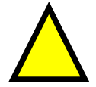

- What should this fire extinguisher be used on? (1 mark)

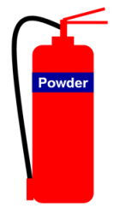

- What should this fire extinguisher be used on? (1 mark)
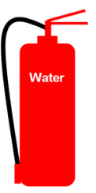

This completes your initial assignment, please check that you have added your name and date to the front of the document before submitting your work

