L3 Fashion & Textiles Summer Homework
Task 1: Unit 52 Textile Design. ‘East meets West’ Moodboard
- From September you will be working to design and create a bag for Unit 52 Textile Design which will be entered into the Shrewsbury Drapers Awards in November.
- Over summer we would like you to collect and collate an A3 moodboard of visual ideas, inspirations, and imagery in response to the theme of ‘East meets West’.
- Consider how you can make the moodboard visually appealing through your use of imagery. Use your own photos/drawings alongside found images from books, magazines, and the internet.
- You can make your moodboard on an A3 piece of card/paper or digitally e.g., on Procreate or PowerPoint.
- From these images and ideas, you will work to develop a series of textile samples as inspiration for your final bag design.
Keywords: TRAVEL / EMBELLISHMENT / FUSION / DECORATIVE / CULTURE CLASH / PATTERN
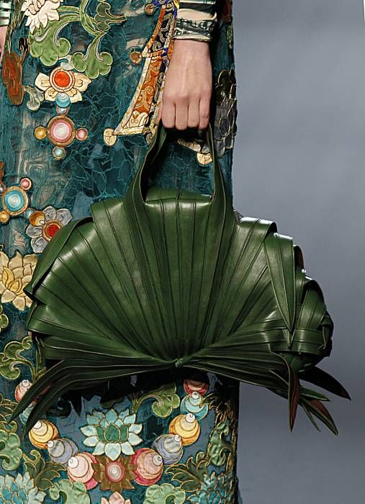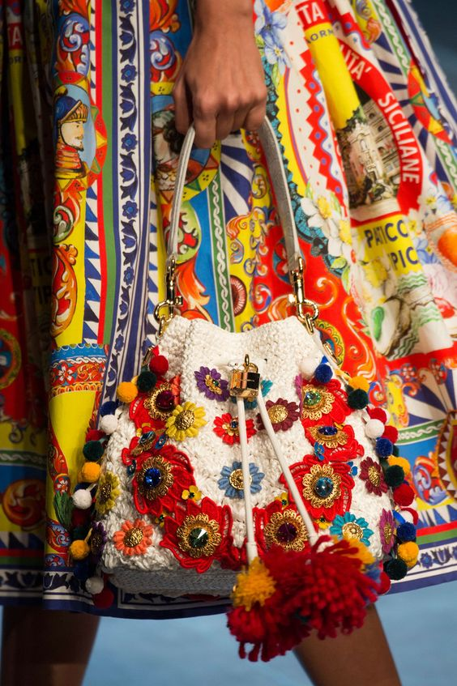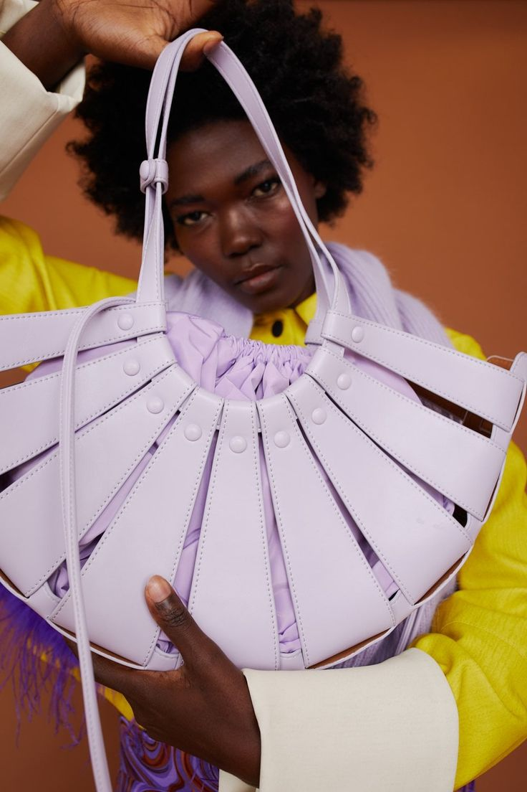

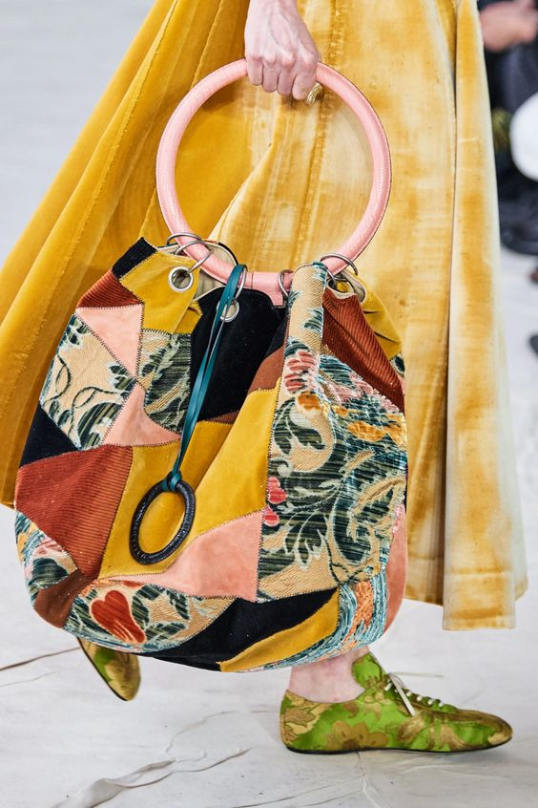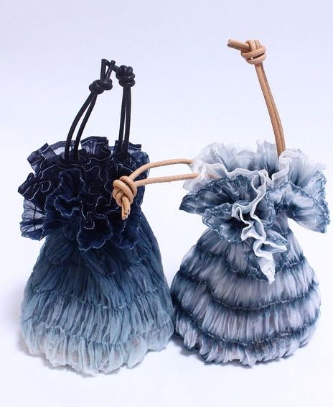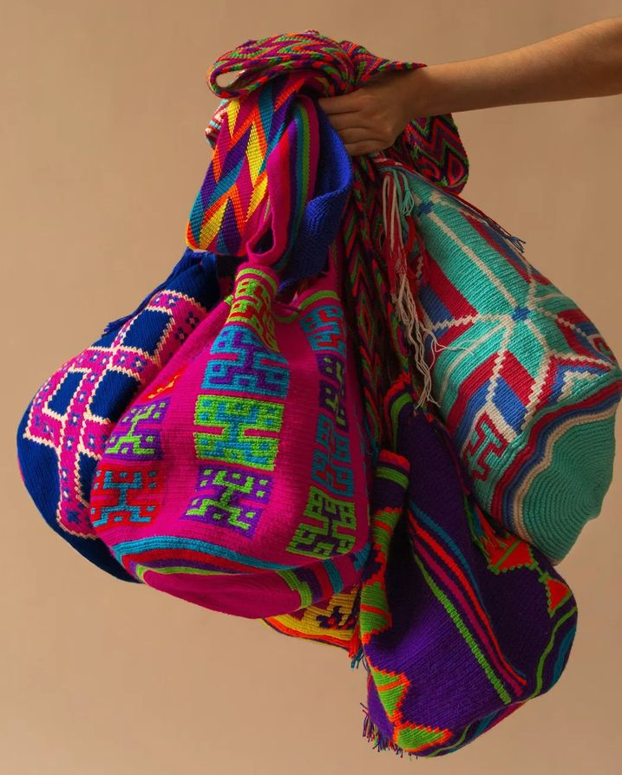

Task 2 : Unit 53 Upcycling Fashion Products. Jeans and a T-Shirt

Sustainability, upcycling, and re-cycling are increasingly evident in the fashion industry as we look to protect the environment and reuse and reimagine existing products rather than creating new ones.

Over summer collect 1x pair of jeans and 1x t-shirt that you will upcycle into a new fashion product.
You may want to collect extra jeans/t-shirts for sampling.

Source images of upcycled fashion product to give you ideas for yours.
Consider embellishment, shape and end uses.

These will form the basis of your upcycling project in term 1.

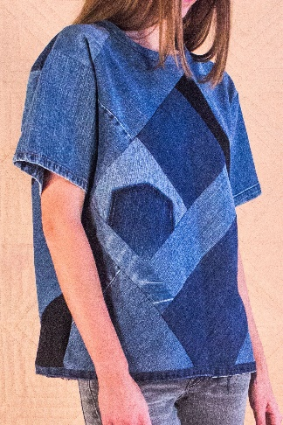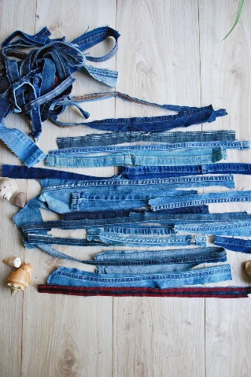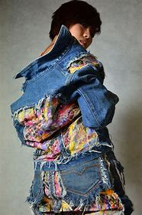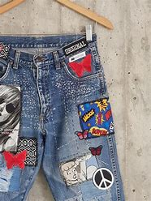

recycle//upcycle//embellish//cut away//reveal//layer//drape//deconstruct //reconstruct//unpick//stitch//reclaimed materials//eco-fashion //sustainable//experimental//environmentally friendly

We look forward to meeting you and seeing your amazing ideas and creativity!
Anna, Clare, Sharon & Helen

