Automotive Department
Summer Project 2021-22
Level 1
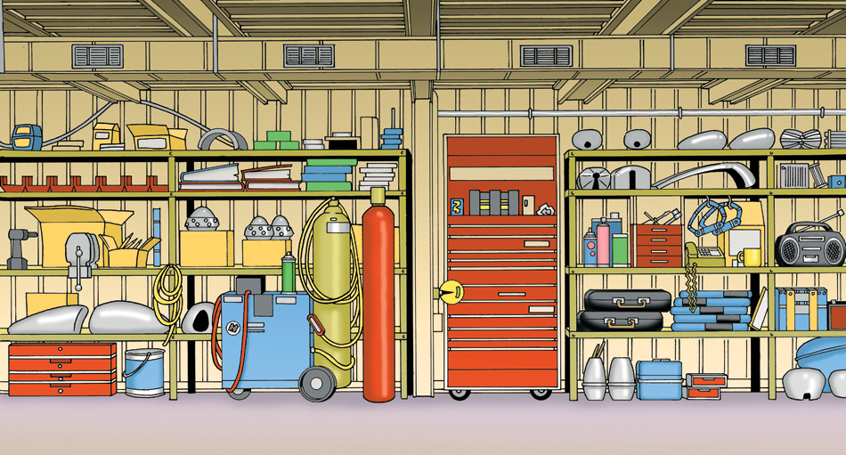

Name: ………………………………………………

Welcome to the automotive department Shrewsbury College. We hope that you enjoy your induction day. Please feel free to speak to a member of the college team if you have any questions.
As part of your induction to Shrewsbury College, you will be given this summer project. This is for you to take away and complete in your own time, during the summer break.
This project is designed to maintain and enhance your chosen course choice and ensure that you arrive ready and focussed when you start your course in September.
Obviously, there may be topics that you have very little or no knowledge of in this assignment. You can use any resource that is available to you to complete this assignment, such as books, videos and of course, the internet in general.
Try to complete all sections of this assignment.
This assignment must be returned when you start your college course in September.

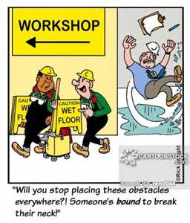
Section 1 Health and Safety

What is the difference between a risk and a hazard?
……………………………………………………………………………………………………………………………………………………………………………………………………………………………………………………………………………………………………………………………………………………………………………………………..

What colours are the following Safety signs?
Prohibited signs …………………………………………………………
Warning signs ……………………………………………………………
Safe condition signs ………………………………………………….
Mandatory signs ……………………………………………………….

What does PPE stand for?
……………………………………………………………………………………………

What does VPE stand for?
……………………………………………………………………………………………

List four items of PPE and state what they protect you from.
Item 1
……………………………………………………………………………………………
Protection from?
………………………………………………………………………………………………………………………………………………………………………………………………
Item 2
………………………………………………………………………………………………
Protection from?
………………………………………………………………………………………………………………………………………………………………………………………………
Item 3
………………………………………………………………………………………………
Protection from?
………………………………………………………………………………………………………………………………………………………………………………………………
Item 4
………………………………………………………………………………………………
Protection from?
………………………………………………………………………………………………………………………………………………………………………………………………

What does the term COSHH stand for?
………………………………………………………………………………………………

What fire preventive material is found inside the following fire extinguishers?
Red Label …………………………………………………………………………..
Blue label …………………………………………………………………………..
Cream label ……………………………………………………………………….
Black label …………………………………………………………………………

Under the Health and Safety at Work Act, safety in the workplace is the responsibility of:
a. the employer alone
b. the employer and the employee
c. an inspector from the Health and Safety
d. the employee alone

What does the term HASAWA stand for?
…………………………………………………………………………………………….

Section 2: Tools, Equipment and Materials

List 3 different types of spanner
1 …………………………………………………………………………………..
2 …………………………………………………………………………………..
3 …………………………………………………………………………………..

What task would require the use of a copper/hide hammer?
………………………………………………………………………………………………………………………………………………………………………………………………

What is the difference between a Phillips and a Pozidrive screwdriver?
………………………………………………………………………………………………………………………………………………………………………………………………
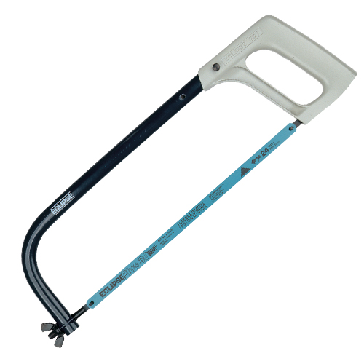
What is the tool in the image?
……………………………………………….
What does TPI stand for in relation
to this tool?
………………………………………………….

Name 3 types of measuring equipment, found in an automotive workshop:
1. ……………………………………………………………………………….
2. ……………………………………………………………………………….
3. ……………………………………………………………………………….

What is meant by the term ferrous metal?
………………………………………………………………………………………..

Name 3 different types of liquids, found in a vehicle:
1. ……………………………………………………………………………………..
2. ……………………………………………………………………………………..
3. ……………………………………………………………………………………..

What is the purpose of the tread on vehicle tyres?
………………………………………………………………………………………………………………………………………………………………………………………………

What is a gasket used for?
………………………………………………………………………………………………………………………………………………………………………………………………

Level 2 Section
This section is to also be completed by next year’s level 2 students.
However, please try to complete this section, even if you are starting on level 1.

Assignment 1 Engines
State the major differences between SI and CI engines. Include as much detail as possible, listing advantages and disadvantages, as well as design differences. Include diagrams.
This assignment needs to be a minimum of 400 words.

Assignment 2 Transmission
State the major differences between front, rear and four-wheel drive vehicle transmission layouts. Include component differences, advantages and disadvantages of these systems.
State the formula for working out gear ratios. State common gear ratios for:
1st gear, 2nd gear, 3rd gear, 4th gear and 5th gear.
What is meant by the final drive gear?
Again include diagrams.
This assignment needs to be a minimum of 400 words.

Assignment 3 Electrical
State the meaning of the following electrical terms:
Voltage
Amperage
Ohms
Watts
State the operating principle of a lead acid battery, include details of its internal construction and operating principles.
Again include diagrams.
This assignment needs to be a minimum of 400 words.

Remember, these assignments are designed to enhance your existing mechanical knowledge, which in turn will improve your success rates when sitting your on-line exams.
It is important, therefore, to avoid copy and paste when completing these assignments. This method will not help you in your future studies and course success, as you will have very little knowledge of what you have copied.
Finally, the secret to completing these assignments is to work little and often. Avoid leaving them until the last minute. You have a long summer break so plan carefully and spread the work out and you will find the tasks much easier to complete.

