New Students Summer Project 2022

Level 3 Extended Diploma in Photography

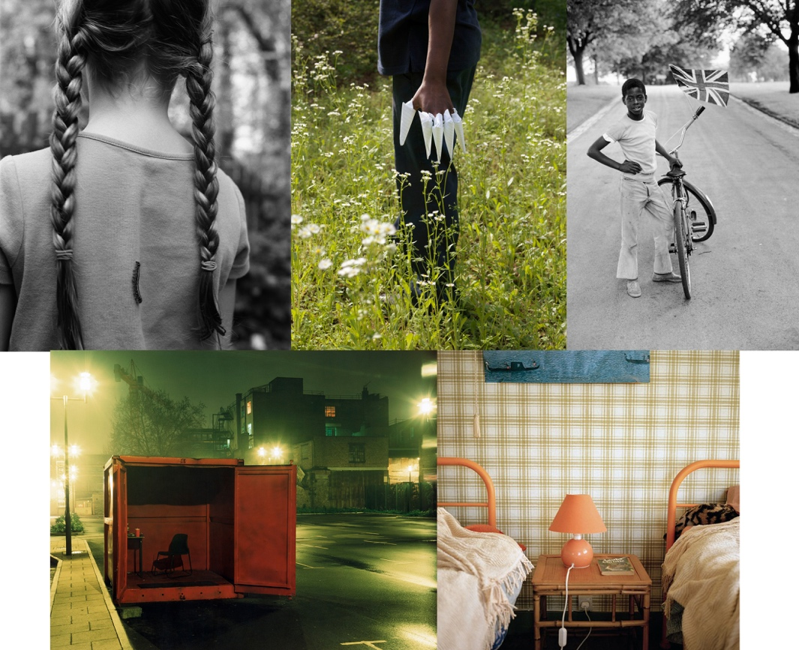
Figure 1 Images clockwise from top: Matt Eich, Alec Soth, Vanley Burke, Marjolaine Ryley, Rut blees Luxemburg

Project Title: Storytelling

Submission date: Start of term, September 2022 (first lesson after enrolment)

Scenario:
We ask you to create work based upon the theme ‘Storytelling’ and produce a series of photographs that work together to tell some sort of story. The work you create will be part of an exhibition of student work exhibited at the college. The story that you choose to present through your images may be fictional, inspired by your imagination, books you read, cinema, music or and other art-forms or it may be fact-based in a more documentary style.

The artwork will be displayed during the first term and we very much want you to be part of this.

What to do:
Over the coming weeks we ask you to create at least 30 (don’t let this be the limit) A5 size photographic-based artworks. See them initially as sketchbook pages then select and develop at least 6 into a final piece. The final selection also needs to be A5 size (A5 is exactly half the size of an A4 piece of paper or postcard size).

The subject of your summer project is completely up to you and may be something of personal interest, for example, documenting youth culture and your friends or something you have access to like family, a club you are involved with or a hobby you have. If you have a particular interest in a genre of photography, for example, fashion photography, landscape or street photography, use this as your starting point.
Media to use:
- The predominant media will be photography and you should use any lens-based media you have access to including digital cameras and phone cameras (try to ensure they are set to high resolution to ensure the quality of the image).
- The work produced can be created in a different media or a combination of media. As photographers we envisage that you will predominately want to focus upon creating photographs – we ask you to be as creative as possible with the way you take the photo and also what you do with some of the photos afterwards. ie: you could work into the photographs using paint, stitch, you could combine two or more images together using simple collage techniques. If you have access to Photoshop or Illustrator you may wish to manipulate the images digitally.

Subject matter:
We are interested in seeing what you find interesting in the world around you ie. family members – parents, grandparents, siblings, friends, clubs and hobbies (yours and your family’s), journeys or places you go, news events, climate protests, the environment, your everyday life, self-portraits or your inner thoughts, fictional stories you create, light and shadow, fashion and style, music, fairytales, etc. Try to be creative in your approach and think about the different ways you can photograph your subject.

Presentation:
- You will be asked to submit your 30 A5 artworks (must have at least 30 – but can be more!) on the first day of teaching.
- You should select your 6 images as a final piece. These should work cohesively as a series and tell a story.
- Please write your name on the back of all your pieces.

Good luck and we look forward to seeing the work you produce.
Follow us on Instagram @shrewscolgroup_photo to see current student work.

Here are some artists who you may find useful who have done similar work:

Alec Soth
Liz Hingley
Rut Blees Luxemburg
Richard Billingham
Vanley Burke
Gregory Crewdson
Cindy Sherman
Tim Walker
Thomas Albdorf - http://thomasalbdorf.com
Matt Eich - http://www.matteichphoto.com/
Sian Davey - https://www.siandavey.com/first-love
https://anewnothing.com

