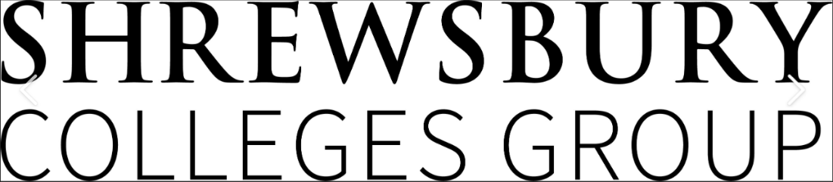
Engineering Summer Assignment for:
C&G Diploma in Engineering
Mechanical Engineering Level 2 2850

September 2023 – July 2024

Name:……………………………………………………………….

Date:…………………………………

Contact Information

Course Leader/Contact | David Vickers
Email | davidv@shrewsbury.ac.uk

Introduction to this summer assignment:

This provides you with:
- An introduction to the course subject material.
- Details of basic resources to use.
- Opportunity to demonstrate how you use research.
- How you will be assessed.
- How you will get feedback
Your chosen course is structured in such a way, as to build upon your knowledge and skills from the very first week of the course, through to the end. You course will be delivered using various methods, from theory based, through to practical workshops.

What is the purpose of this assignment?
To demonstrate what you have learned in the welcome sessions and how you can expand this, using research from links provided and further research from websites and further reading which is available from a library or other free resources.
This will link to the two units covered in the first term of the academic year starting in September 2022.

These units are listed below:

Unit 201 Working in Engineering Sept 22 – December 22

This is a theory-based unit delivered in a classroom environment covering all aspects of working within an engineering environment. Subjects include:
Learning outcomes
There are four learning outcomes to this unit. The learner will:
1. Know engineering health and safety requirements
2. Know effective methods of communication
3. Understand drawings and specifications
4. Know about working in engineering
Online Multiple choice test 3rd week November, 1st week of December

Unit 206 - Using Bench Fitting Techniques Sept 19 – December 19

Workshop based activities developing hand fitting techniques,
Learning outcomes
There are two outcomes to this unit. The learner will:
1. Know how to plan and prepare for bench fitting activities
2. Be able to apply bench fitting techniques to produce component parts
Assessment as of this test phase and the workbook that accompanies it. With the short answer question paper.

Free resources list for both online and public library

Health and safety:
HSE: Information about health and safety at work, covering COSHH, PPE, PUWER, accidents in the workplace and regulations.
https://www.hse.gov.uk/
Resource link to unit 201 see below:

201 handout complete .pdf

Hand fitting resources.

https://shrewsburycollege-my.sharepoint.com/:p:/g/personal/davidv_shrewsbury_ac_uk/EXRj_6S6ls5IqqM-iJGXGPcBi5P0LiPotnTCj7yegf_QrA?e=es2L1F

https://shrewsburycollege-my.sharepoint.com/:p:/g/personal/davidv_shrewsbury_ac_uk/EUFTh6V0_qpGmJ1kShfUPLoB9Cika4u8VOWBYT7juAipKg?e=p1Zv45

How will you be assessed?

You will be asked questions in the assignment paper and see the appropriate marks for the complexity of answer required.
Example 1:
Name two hazards that are present with a MIG welding process? (2 marks)
Example 2:
Name two hazards of a MIG welding process and state what safety equipment you would use to protect the person welding, from these hazards? (4 marks)

How will you get feedback?
You will hand the assignment in to your subject tutor at the start of the academic term and they will mark the document and give written feedback alongside the score of what you have achieved, ready for the following week.
This will help you to prepare for upcoming theory and practical sessions, and give you focus towards the progress tests that are 4 weeks into the new term.
Remember to submit your work in a presentable manner, if it cannot be read by the person marking, it will not achieve marks for that question.

Assignment Question Paper Level 2 Manufacturing

- State three hazards associated with hand fitting (3 marks)

- For each hazard state the personel protective equipment (PPE) that should be worn. (3 marks)

- What is COSHH, what does it cover and how does it apply to Hand fitting (6 marks)

- What is PUWER, what does it cover and how does it apply to the workplace? (6 marks)

- What is RIDDOR, what does it cover and when does it apply? (6 marks)

- Draw the symbol for first angle projection (2 marks)

- Draw the symbol for third angle projection (2 marks)

- List 10 Employers responsibility to employees in the workplace.
(10 marks)

- What is this safety sign (1 mark)

- What is this safety sign (1 markl)

- What should this fire extinguisher be used for? (1 mark)

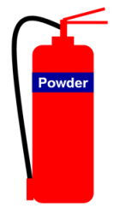

- What should this fire extinguisher NOT be used for? (1 mark)

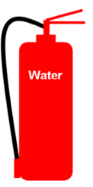

- State the difference between a HAMMER and a MALLET (2 marks)

- What is the RANGE of a micrometer? (1 mark)

- State the 2 Types of cut of a file. (2 marks)

- State the 3 grades of a file. (3 marks)

This completes your initial assignment, please check that you have added your name and date to the front of the document before submitting your work

