Music Technology – Summer Assignment 349 – Planning a Career in Music
Music Technology Summer Assignment Issue Date: July 2023
Due Date: 4th September 2023
Your Roles within the Sound & Music Industry
Intro:
One of the core units you will have to study on Music Technology is Unit 349: Planning for a career in Music. This unit will expose you to the career paths that are available within the world of music as well as encouraging you to create your own original business ideas.
During the summer break you will research two job roles that you feel are areas that you would be capable of working in. You will include a job description for each job roles (this should include research from reputable sources) and a list of the skills you feel that you have that would make these jobs suitable for you.
This research and self-assessment task will cover Learning Outcome 2 from Unit 349 and on completion you will be used to achieve a pass, merit or distinction grade for the unit overall.
------------------------------------------------------------------------------------------------------------------
Your completed report should be submitted to your tutor on your first day of induction week at the beginning of September.
Task 1
- Think about the skills you already possess. i.e. Are you proficient in your instrument? How do you know? Have you taken grades? Any formal qualifications? Do you have excellent networking skills? How are you talking to new people? Do you have a big, varied friendship group? What is your social media profile like? Is it professional or more personal? If you google yourself, what do you find? Would you be happy for an employer to see that?
- Write down a comprehensive list of skills you think you already process and say why. Task 2
- Research two job roles that you are interested in and write a job description for both and include a possible salary and personal and professional skills they require.
- Add a paragraph at the end saying how suitable you are for these roles based on the skills you have assessed yourself as having. Please reference any outside resources you use.
- Send to bethmc@shrewsbury.ac.uk on the first day of your induction week.
Tips for Research:

Music Technology – Summer Assignment 349 – Planning a Career in Music
- When carrying out research work like this for your RSL Level 3 course detail is key. The more detail you can add to your work the better your chance of achieving a higher grade.
- Be sure to use reliable sources. Good online examples are listed below. Steer away from using unreliable sources such as online forums and places where people can add false information such as Wikipedia (however, this website can be a good starting point).
- Avoid plagiarism (copying directly from sources of information or copying directly from your friends). This could land you in serious trouble with exclusion from the course.
- Use real books. There are plenty in the college library relating to music and music technology.
- Add a bibliography at the end of your report. This will list all of the books, journals, magazines and websites you used to create your work.
Usually you will only ever get one chance to submit a piece of coursework. Therefore make it your best. You can ask a tutor to check your work before submitting it to make sure it is meeting the appropriate criteria. It is essential that this is done well before the assignment deadline.
Useful Resources:
www.bbc.co.uk/introducing
uk.music-jobs.com
www.careersinmusic.com
www.live-recruitment.co.uk

Continue on the next page for part 2 of this assignment. Thank you.

Computers today are paramount in the production of music. The invention of sequencing has enabled us to create and record music through a piece of software. The sequencer is used in numerous applications from recording in a studio, sequencing a dance track or audio production for the visual image. It is important not only for producers but also musicians to gain an understanding of how sequencing works. This project will give you an insight into the area of Music Sequencing & Production. Just think about how often you hear recorded sound and music, it has all been recorded, created, edited, written, composed, mixed, shared, uploaded etc. This area is related to all of these. In the Music Technology department we operate with Logic Pro X and Pro Tools, this project will utilise online and other software packages but the skills and techniques are all transferable.
- Develop skills in music sequencing
- Understand the application of music sequencing skills in industry roles
All students on all courses here will study music sequencing at all levels from 2 to 4 (Higher National Certificate). Music sequencing is an integral part of industry practice. The skills and techniques utilised in music sequencing are related to many other areas. Some of the key skills include: composing, MIDI editing, audio editing, changing levels, pan positions, audio processing, adding effects, automation, remixing and recording. These skills are transferable to projects related to working in a recording studio, working in Radio, TV and Film production, composition, song writing, remixing and sound engineering.
Music Sequencing & Production
Visit https://soundation.com/ click on the link and select the free option. You can sign up with an email address or through Facebook.
In the tabs across the top choose learn.
Follow the guidance in the ‘get started in 15 minutes’ section. By selecting the Studio section you will be taken to the production area where you can put your new found skills into practice.
Once you have mastered the basics you should move up onto the more advanced section.
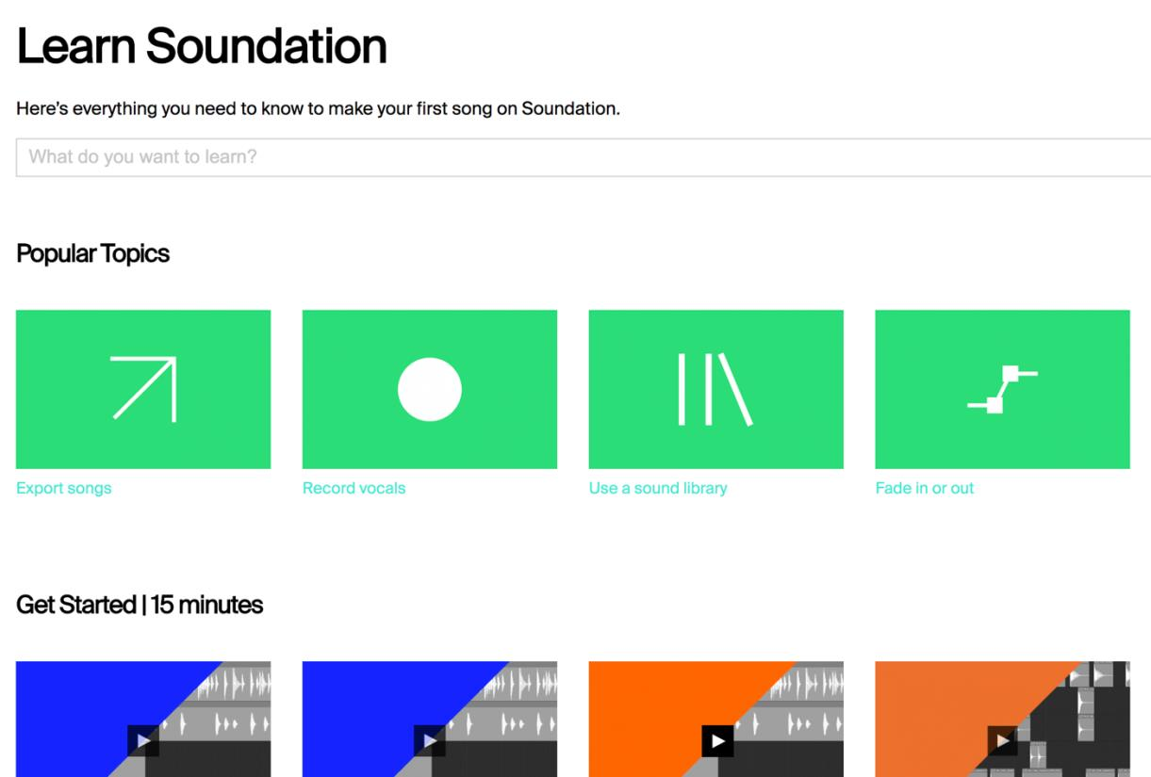TW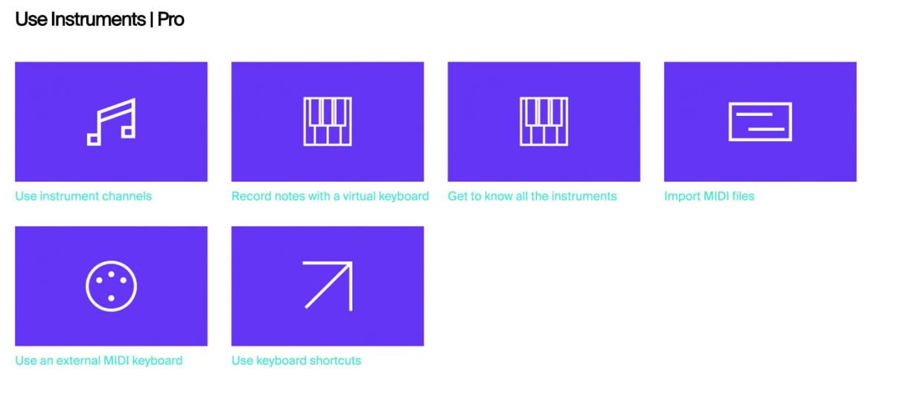

Make some music!
Using your new found skills, practice making music and see what you can create.
You’ll be able to export your track as an MP3 once it is complete.
Submit a copy of your composition to ianr@shrewsbury.ac.uk during the induction week.
If you have your own computer you will be able to install and work with other software. We understand that not all of you will be able to do this but it is worth taking a look at the software online.
Pro Tools First which is available by the link below is a cut down version of the leading music production software Pro Tools which is used by the BBC, Film and TV editors and in recording studios the world over. Follow the instructions and have a go at recording and mixing.
https://my.avid.com/get/pro-tools-first
Another software which is widely used for Live Performance and composition is Ableton Live. Unlike a traditional music sequencing software the sounds, loops and sound effects can be triggered live. Disclosure are one of the biggest users. See this video about their set up here https://www.youtube.com/watch?v=cXaBgCuTAtY You can download Ableton Live Lite for free here
https://www.ableton.com/en/products/live-lite/ Have a go and see what you can create, Live is a great software as it has an in built guide on the right hand side that walks you through the software.
We recommend that you invest in some headphones, you will be spending a lot of time working on your compositions and recordings as well as in the studios. Ideally they will be closed back over ear. These will range from £20 for a budget set up to around £100 for professional quality. We recommend either AKG, Sony or Roland.
It is also worth buying a memory stick with at least 32GB of space to save and back up your projects.
If you have any questions please email ianr@shrewsbury.ac.uk or bethmc@shrewsbury.ac.uk
Stay safe and we will see you in late summer!

