Travel & Tourism Homework

- Visitor Attractions: Write a list of the products and services they offer customers at:
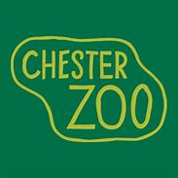
- Chester Zoo

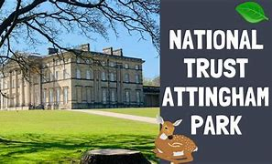
- Attingham Park (National Trust)

- Work experience: Research and propose two suitable potential work experience placements. Including:
- Describe the organisation.
- Potential roles
- Any constraints that may affect your choice of placement?

- Global Destinations: You have a ticket to go anywhere in the world!
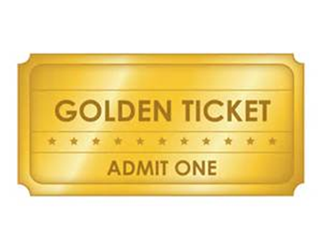
Where do you want to go? Create a poster to show the top 3 destinations you would like to visit. Include:
- Destination information (Country, continent, currency, capital city, flag, location, customs and traditions, food and drink, top attractions/things to do or see, flight time from the UK, etc)
- Accommodation options
- Why you’d like to visit there?

